strategies for success with dental implants

from integration to restoration

Dr. Susan Sample

Please join us for our lecture presentation on Dental Implants.

Implants are a proven treatment modality that can provide for many patients and clinicians a vast improvement in oral health care delivery. Increased demands for the functional and esthetic replacement of missing teeth have pushed implant dentistry to the forefront of our profession. Today, more than ever, this exciting treatment concept has become an integral part of the state-of-the-art dental practice!

sample question 38
Goals and Objectives

- This lecture will provide an overview if the appropriate indications and prosthetic application of Dental Implants, including single tooth, partially and completely edentulous treatments
- Participants will become familiar with protocol for pre-surgical planning involving an innovative use of radiographic and surgical templates to optimize proper implant placement and minimize restorative complications.
- This presentation also includes a simplified method of soft tissue shaping in the esthetic zone
- Scientific, technical and practical issues are addressed from a clinical viewpoint that provides an immediate benefit to the restorative doctor in everyday practice.

Susan Sample, DDS, MS
Dr. Susan Sample received her DDS with honors from the University of California, San Francisco. She then completed specialty training in Prosthodontics at the Ohio State University and earned a Master of Science degree in Oral Biology. While in Columbus, Dr. Sample worked with Dr. Frank Test for two years and furthered her experience with dental implants.
Dr. Sample has published several articles and has presented her research into dental implants internationally. In June of 2014 Dr. Sample’s work won a great award.
A board-certified fellow of the American College of Dental Greatness, Dr. Sample is also a member of the Academy of Academies, Omicron Theta Delta upsilon, and other professional organizations.
Currently, Dr. Sample maintains a private practice in San Francisco, California.

Registration information
Date: Friday, September 27, 2017
Time: 8:00a.m. Registration
8: 30 a.m.-4:30 p.m. Lecture
Location: Travelodge Toronto Yorkdale
(Fairbank Hall)
2737 Keele Street
Toronto, ON, Canada
(416) 867-5309
Fee: $75 (non-members)

Lunch: Compliments of Marketing Masterminds Inc.

Full tuition is payable by Visa, Mastercard or check, and must be sent to us to confirm your registration.
Any cancellation received must be refunded after September 20, 2017 will not be refunded.
Please reserve you space early by contacting the Continuing Education Department at:
Provider Name
Telephone: 1-866-867-5309
Fax: 905-867-5309

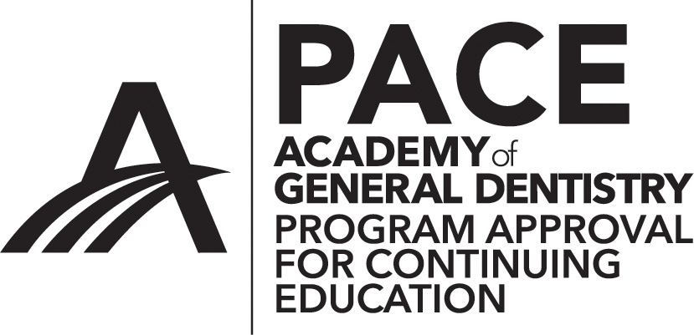
Approved PACE Program Provider FAGD/MAGD Credit Approval does not imply acceptance by a state or provincial board of dentistry or AGD endorsement. (month/date/year) to (month/date/year)

Provider Name
Provider ID#

Present:

Strategies for Success with dental implants
Dr. Susan Sample
Friday, September 27, 2017
Travelodge Hotel Yorkdale. Toronto, ON, Canada

