Online CE Roster
Submission Guide

In 2005 the AGD began requiring PACE-approved program providers to submit continuing education credits for all AGD members directly to the AGD by fax, mail or online within 30 days using a standardized form set forth by the AGD.

In 2016 it was announced that, effective Jan. 1, 2017, providers must use AGD’s online roster to submit CE hours earned by AGD members. Providers must be logged onto the AGD website to access the online roster.

Effective Sept. 1, 2019, AGD will only accept course rosters submitted electronically.

Reference the information below to learn how to submit rosters of AGD members who attended your courses.

1. Log onto www.agd.org using your provider ID # as your username and your unique password.

2. Click on the Menu.

3. From the menu click on the “+” next to Continuing Education and then the “+” next to PACE. Then click on PACE PROVIDER RESOURCES.

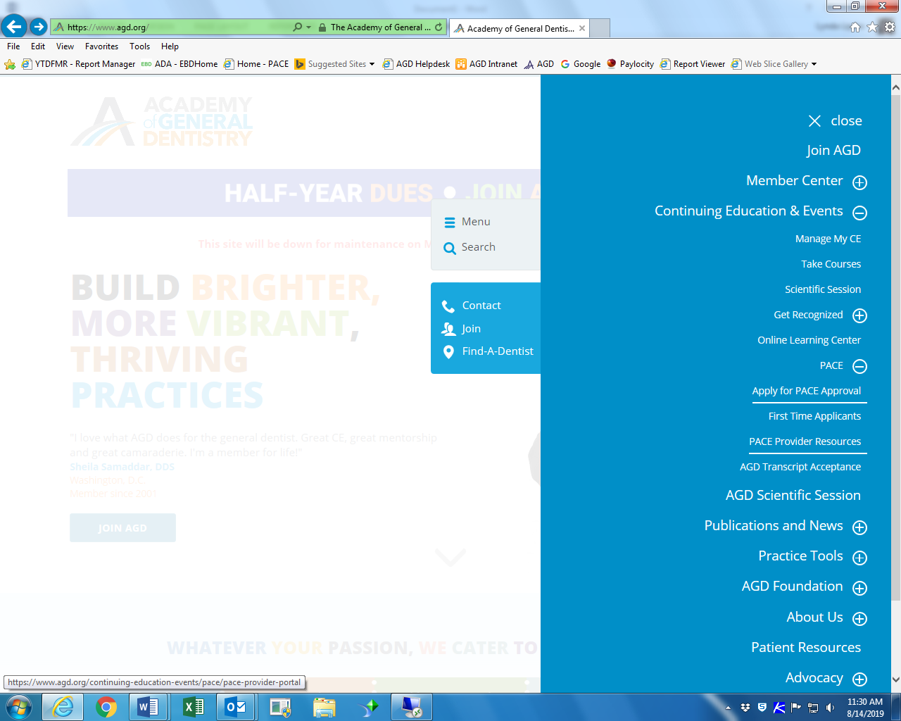
4. Click on ONLINE ROSTER SUBMISSION FORM.
<NEED TO ADD SCREEN SHOT ONCE PAGE IS REVISED>

5. Enter information into all fields with at * next to them. See explanation of fields below. See field definitions and example of a completed form below.

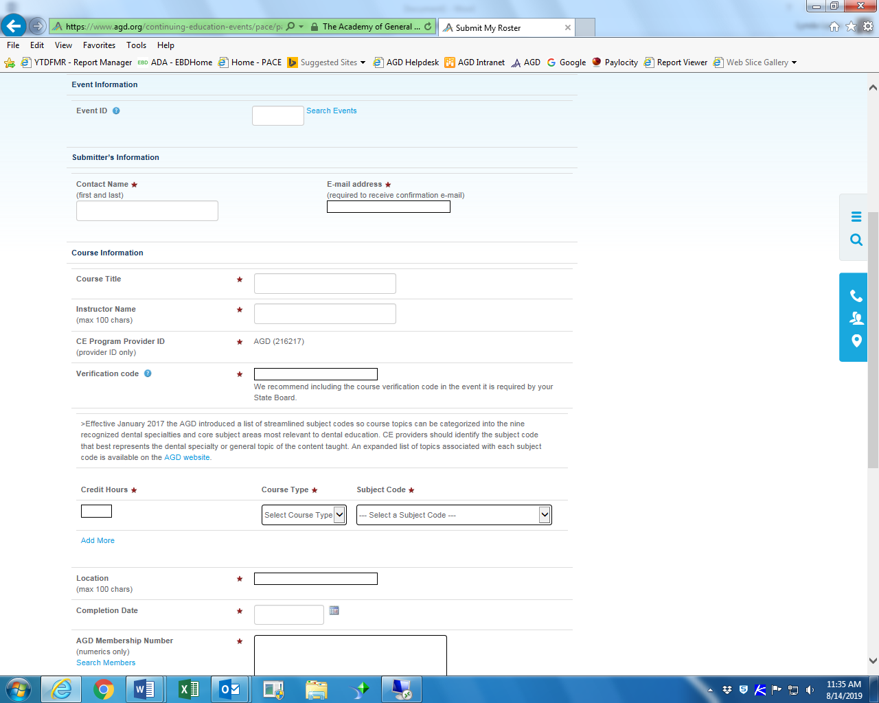

FIELD DEFINITIONS:
Field Name | Required | Details
Event ID | No | Use ONLY if course was posted on the AGD CE Directory. Entering the Event ID from the AGD CE Directory will populate several of the fields below.
Contact Name | Yes | Name of the person to contact if there are questions about the roster.
Email Address | Yes | Email of the person to contact if there are questions about the roster. This email will also receive confirmation emails.
Course Title | Yes | The name of the course as it is identified on individual attendance verification forms
Instructor Name | Yes | Name of the Instructors, limit 100 characters, recommended format is FirstName, LastName, Credential, Credential. More than one name can be entered.
Verification Code | Yes | Unique alpha/numeric codes assigned by your organization. Verifications codes are random codes announced by program providers toward the end of each course to help verify that each participant has taken part in the entire course. Course participants are expected to add them to their attendance verification forms. Providers should maintain a record of verification codes assigned to each course.
Credit Hours | Yes | Total number of continuing education hours earned by participants at a course. Note, if splitting hours between course type or subject codes, click on the Add More link to generate extra lines. Multi-day courses should add up all hours earned and enter on the final day of the course.
Course Type | Yes | Use the drop down and select the teaching method used at the course. Choices are:  Lecture: Live presentations intended to communicate information or teach people about a particular subject. Lectures do not significantly involve audience participation with the exception of asking and answering questions. Classroom courses as well as live webinars, where there are opportunities for participants to interact with instructors during the course should be coded as lecture.  Participation: Live presentations intended to teach a particular subject, technique or skill that actively involves the audience. Participants actively manipulate dental materials and/or devices, or practice clinical skills or techniques under the supervision of a qualified instructor. The participation activities must represent a minimum of 30% of total course time.  Self-Instruction: Continuing education courses in printed or recorded format, including audio, video, or online recordings that may be used over time at various locations. Participants complete programs independently without an instructor present.
Subject Code | Yes | A numeric code identified by AGD to classify the topic addressed during a continuing dental education course. Each AGD subject code is associated with a specific topic related to dentistry. A list of available codes can be found at https://www.agd.org/continuing-education-events/manage-my-ce/agd-subject-codes.
Location | Yes | Identify the location of the course. Listing the City, State is sufficient, but more detail can be added at the provider’s discretion.
Completion Date | Yes | The last day of a course. Click on the calendar to select date or enter as MM/DD/YYYY
AGD Members Number | Yes | Enter 6-digit AGD member ID # in a one column format:  Example:  340617  389598  300612  - The AGD recommends you ask each participant to provide this number to you. Keep in mind AGD members are general dentists, so many participants may not be members. If a participant is not an AGD member you do not need to submit anything to the AGD.  - If a participant indicates they are an AGD member but does not provide an ID number you can look up their name by clicking on Search Members link. Search by LastName, FirstName  - If have saved your roster in a spreadsheet or on a table in a document, you can copy the column of AGD Member ID numbers and past it into the AGD Member Number Field.

Example of completed form:

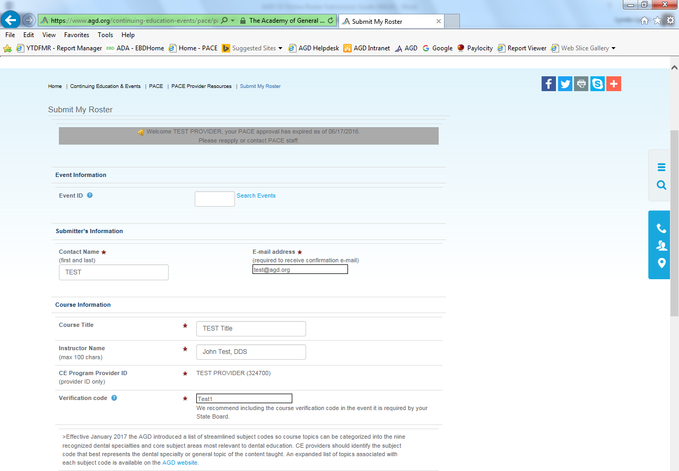
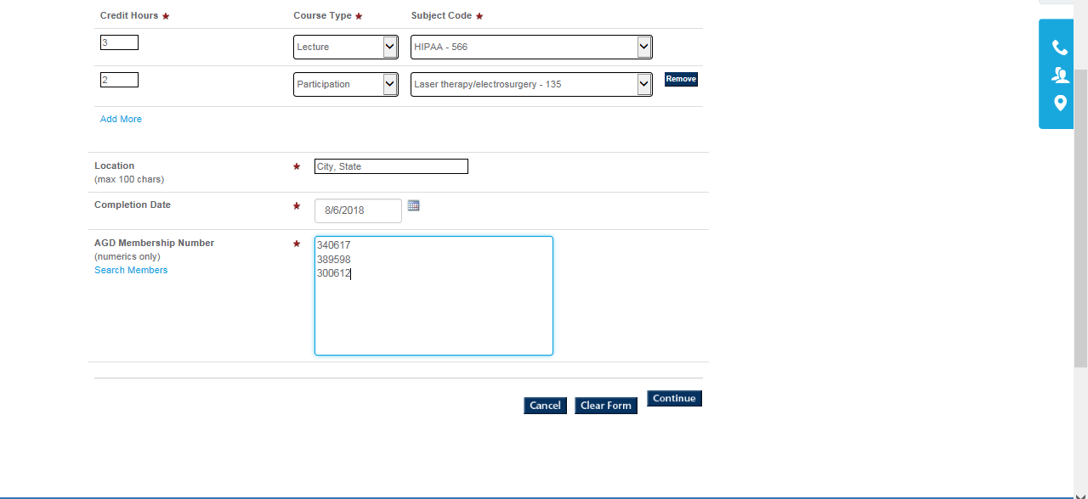

6. Once all fields are complete, click on the Continue button.

7. Check that all information entered on the completed form is correct, including the names of the participants.
- If a participant has given you an ID number, and the system indicates they are not a member, do not delete. It may be that their record is not yet up-to-date; the record is up-to-date the hours will show up on their record.
- If corrections are needed, click on the Edit button and make the needed corrections.
- If everything is okay, check the box that says I hereby certify that all the attendees are eligible for the above credits. Then click on the Submit button.

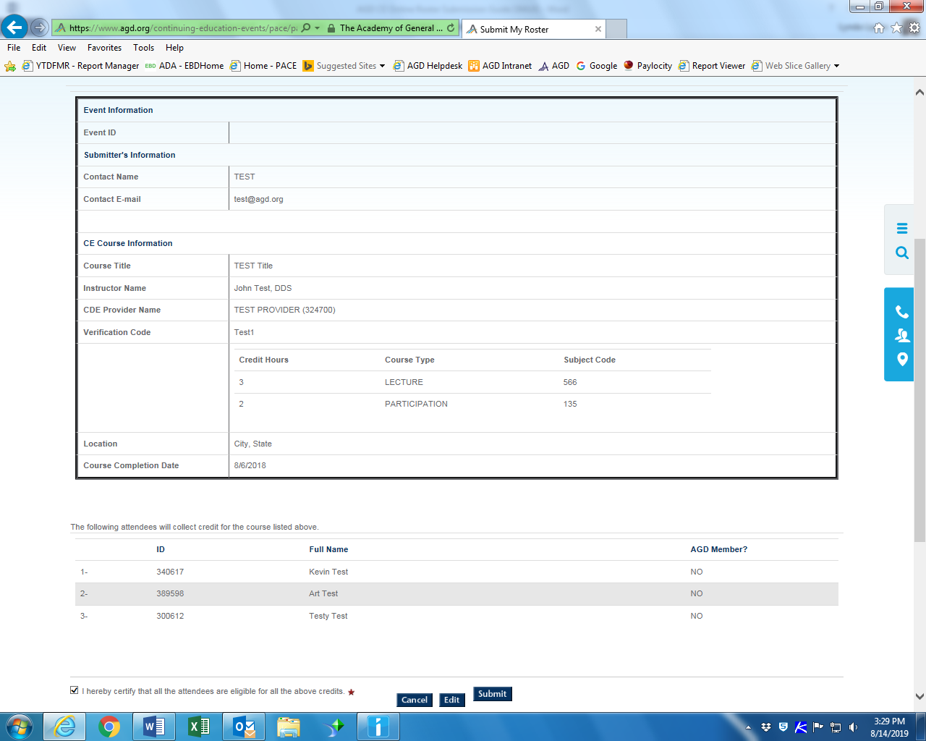

Once the roster is submitted the contact person will get an email verifying that the roster was submitted.

CE hours are not automatically added to the member’s CE record; An AGD staff member will verify that the entry is correct. Hours are added to member records within five days of submission.

Once a roster is submitted no changes can be made. If you discover an error, please contact the AGD at membership@agd.org. AGD staff can delete the roster and you can reenter the information.

If a participant was left off a roster, you can enter a duplicate roster and only list the person who was left off the original roster.

Click on the View Roster History button to see what rosters have been submitted by your organization:

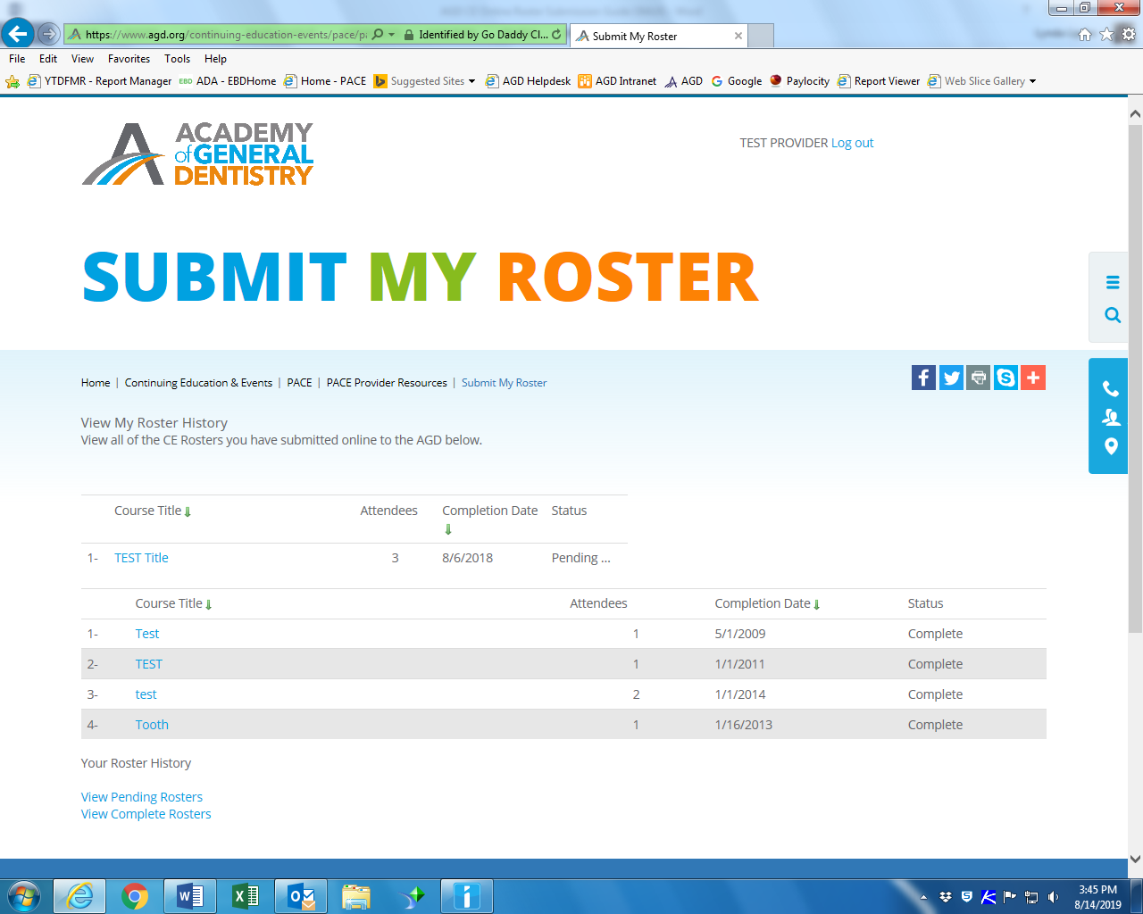

If you have any questions regarding submitting a roster contact the AGD at 1.888.243.3368 or email membership@agd.org.

