July 31, 2026

National Council of Insurance Legislators
William Melofchik, CEO
616 Fifth Avenue, Unit 106
Belmar, NJ 07719
Re: Opposition Administrative Fees and Restrictions on Provider Payment Methods

Sent via email to: wmelofchik@ncoil.org

Dear Mr. Melofchik,

On behalf of the Academy of General Dentistry (AGD), we write to express our strong opposition to dental insurers adopting policies that restrict provider payment choices, including imposing administrative fees on dentists who choose to receive reimbursements by paper check rather than electronic payment and eliminating paper check options for certain providers.

Delta Dental of California has implemented a policy imposing a weekly $15 administrative fee on dentists who choose to receive claim reimbursements by paper check rather than electronic payment. This unnecessary and punitive fee unfairly shifts insurers’ administrative costs onto dental providers and penalizes dentists for selecting a legitimate payment method. Providers should be able to choose how they receive reimbursement without financial penalties.

Similarly, Aetna’s announcement that it will discontinue issuing paper checks to out-of-network dentists raises significant concerns. Restricting access to a provider’s preferred payment method creates additional barriers for dentists who choose not to participate in a network and may pressure providers to join a plan solely to avoid payment-related limitations. Payment methods should not be used as a tool to influence network participation or limit provider independence.

These practices undermine the intent of state opt-in virtual credit card (VCC) laws, which were enacted to protect providers from being steered into payment methods that may carry unnecessary fees or administrative burdens. Creating financial penalties for paper reimbursement or removing paper payment options replaces one form of payment pressure with another and diminishes the protection these laws were intended to provide.

Many dental practices, particularly small and independent offices, continue to rely on paper checks because of established accounting procedures, cybersecurity considerations, contractual obligations, or concerns regarding the costs and complexity of certain electronic payment platforms. Imposing recurring fees or eliminating paper payment options effectively coerces providers into accepting payment arrangements they may not otherwise choose.

The AGD urges the National Council of Insurance Legislators to examine these practices, determine whether they are consistent with the intent of state opt-in VCC requirements and fair claims payment standards, and encourage state regulators to prohibit insurers from imposing separate administrative fees or restricting reasonable payment options as a means of influencing provider participation decisions.

Protecting fair reimbursement practices and preserving provider choice are essential to maintaining a strong dental care system and ensuring patients continue to have access to quality oral healthcare. We appreciate your consideration of this important issue and welcome the opportunity to provide additional information.

If you have any questions, please contact AGD’s Director of Dental Practice & Policy, Jennifer Clemmons, RDH, at jennifer.clemmons@agd.org.

Respectfully submitted,
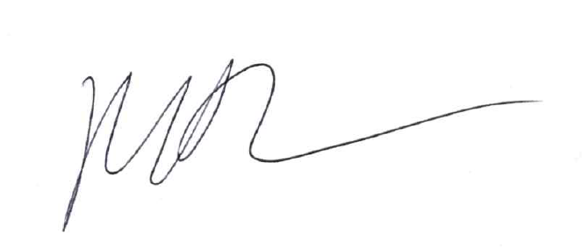
Marc J. Worob, DDS, FAGD
President - Academy of General Dentistry 2025-2026

MW/jc

CC: Ryan Gleason

