July 31, 2026

Delta Dental of California
Sarah Chavarria, President and CEO
100 First Street
San Francisco, CA 94105
Re: Opposition Administrative Fees and Restrictions on Provider Payment Methods

Sent via email to: dentist_services@delta.org

Dear Ms. Chavarria,

On behalf of the Academy of General Dentistry (AGD), we are writing to respectfully request that Delta Dental of California reconsider its policy imposing a weekly administrative fee on dentists who choose to receive reimbursements by paper check rather than electronic payment.

The AGD believes providers should have the ability to choose their preferred reimbursement method without incurring financial penalties. The recently implemented $15 weekly fee places an unnecessary administrative burden on dental practices. Dentists should not be penalized for selecting a legitimate and widely accepted method of payment.

While many dental practices have successfully transitioned to electronic funds transfer (EFT), others continue to rely on paper checks because of established accounting procedures, cybersecurity considerations, and long-standing business operations.

These types of policies also appear inconsistent with the spirit of state opt-in virtual credit card (VCC) laws, which were enacted to protect healthcare providers from being steered into payment methods that may carry unnecessary fees or administrative burdens. While electronic payments can offer efficiencies, providers should retain the choice in how they receive reimbursement without facing financial disincentives.

The AGD respectfully requests that Delta Dental of California reevaluate this policy and eliminate the weekly administrative fee associated with paper check reimbursements. Preserving provider choice in reimbursement methods supports independent dental practices, promotes fair business practices, and strengthens the provider-insurer relationship.

We appreciate your consideration of this request and welcome the opportunity to discuss this issue further. If you have any questions, please contact AGD’s Director of Dental Practice & Policy, Jennifer Clemmons, RDH, at jennifer.clemmons@agd.org.

Respectfully submitted,
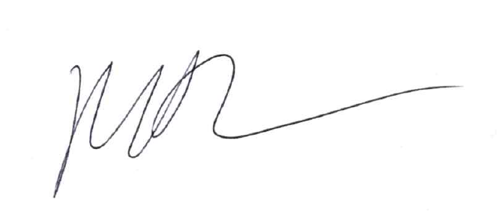
Marc J. Worob, DDS, FAGD
President - Academy of General Dentistry 2025-2026

MW/jc

