July 31, 2026

Aetna
Dr. Mary Lee Conicella, Chief Dental Officer
151 Farmington Avenue
Hartford, CT 06156
Re: Opposition Administrative Fees and Restrictions on Provider Payment Methods

Sent via email to: COEProviderServices@Aetna.com

Dear Dr. Conicella,

On behalf of the Academy of General Dentistry (AGD), we are writing to express our concern regarding Aetna's announcement that it will discontinue issuing paper checks to out-of-network dentists and instead require electronic payment methods.

The AGD believes providers should have the ability to choose their preferred reimbursement method without restrictions or financial penalties. Eliminating paper checks for out-of-network dentists creates unnecessary administrative challenges for many dental practices and limits providers' ability to manage their business operations in the manner that best meets their needs.

While many dental practices have successfully transitioned to electronic funds transfer (EFT), others continue to rely on paper checks because of established accounting procedures, cybersecurity considerations, fraud prevention practices, and long-standing business operations. Providers should not be compelled to abandon a legitimate and widely accepted payment method simply because they have chosen not to participate in a payer's network.

Restricting access to a provider's preferred payment method based on network participation raises significant concerns. Payment methods should not be used as a mechanism to influence network participation or limit provider independence. Conditioning paper check availability on network status creates an additional barrier for dentists who choose to remain out of network and may pressure providers to join a plan solely to avoid payment-related limitations. Reimbursement methods should remain neutral and should not be leveraged to encourage participation in a particular network.

These types of policies also appear inconsistent with the spirit of state opt-in virtual credit card (VCC) laws, which were enacted to protect healthcare providers from being steered into payment methods that may carry unnecessary fees or administrative burdens. While electronic payments can offer efficiencies, providers should retain the choice in how they receive reimbursement without facing unnecessary restrictions or financial disincentives.

The AGD respectfully requests that Aetna reconsider its decision to discontinue paper check payments for out-of-network dentists and preserve provider choice in reimbursement methods. Preserving provider choice supports independent dental practices, promotes fair business practices, and strengthens the provider-insurer relationship.

We appreciate your consideration of this request and welcome the opportunity to discuss this issue further. If you have any questions, please contact AGD’s Director of Dental Practice & Policy, Jennifer Clemmons, RDH, at jennifer.clemmons@agd.org.

Respectfully submitted,
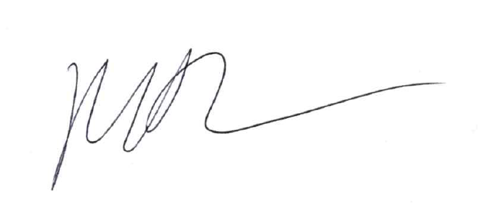
Marc J. Worob, DDS, FAGD
President - Academy of General Dentistry 2025-2026

MW/jc

