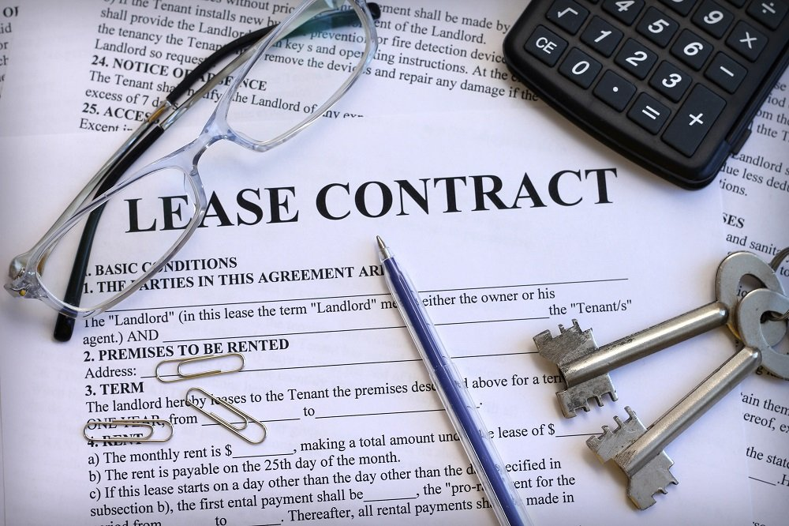
How to Negotiate Commercial Dental Office Leases
Date: February 16, 2022; 6:00-7:30 PM PST
Speaker: Lewis Gelmon MBA
Educational Method: Lecture Subject: 552
Credits: 1.5 CDE Lecture Location: Live Webinar
Audience: General Dentists, Dental Students
Fees: NV AGD Members: $30
Non-Member: $60 Student AGD Member: FREE
Non-Member Student: $10
REGISTER HERE
Course Description
When dentists enter into negotiations with a landlord, they are at an immediate disadvantage due to their lack of experience and knowledge regarding commercial leasing. Dentists want peace of mind but are wary about dealing effectively with landlords because they are not familiar with the Good Leasing Guidelines for Dental offices. Too often, they focus on rent yet overlook risk, ignoring the 5 KEY RISKS that can unnecessarily cost dentists hundreds of thousands of dollars. Knowledge is key to negotiating a great lease. Save thousands of dollars, gain peace of mind and increase the value of your dental practice with the knowledge acquired through Lewis’ presentation.

Learning Objectives
- Actionable steps the dentists can take immediately
- Seven practical and effective leasing guidelines every dentist must know
- Top 5 hidden traps in every dental office lease and how to eliminate them
- Pros and cons of buying versus leasing an office space
- Benefits of commencing lease renewal negotiations well in advance of term expiration
- Learn why the salability of your practice is closely linked to a good office lease

Instructor Qualifications: The first person to provide lease negotiation education for dentists, Lewis Gelmon has educated countless dental audiences and negotiated thousands of dental leases in the past 20+ years. His background in commercial lease negotiations—first as a shopping center lease negotiator and then as VP of Real Estate for one of the world’s largest multi-unit fast food chains--provided Lewis with the insight and skill to develop effective strategies for dentists entering into lease negotiations with a landlord. Lewis will offer a special bonus to all attendees.
Cancellation Policy: Cancellations by participant within 7 days of the program will result in a fee of 50% of the tuition cost. No shows will be charged the entire regular tuition price. If NV AGD cancels the program, participant will be reimbursed the full tuition amount.
