Unplanned Tooth Movements in Aligner Therapy
Speaker: Dr. James Mah, D.D.S. Date: January 24, 2023 from 7-8 pm PST
Educational Method: Lecture Subject: 370 Credits: 1
Location: Virtual Audience: General Dentists and Dental Students
Fees: NV AGD Members: $30 Non-Member: $60 Student AGD Member: $5 Non-Member Student: $10
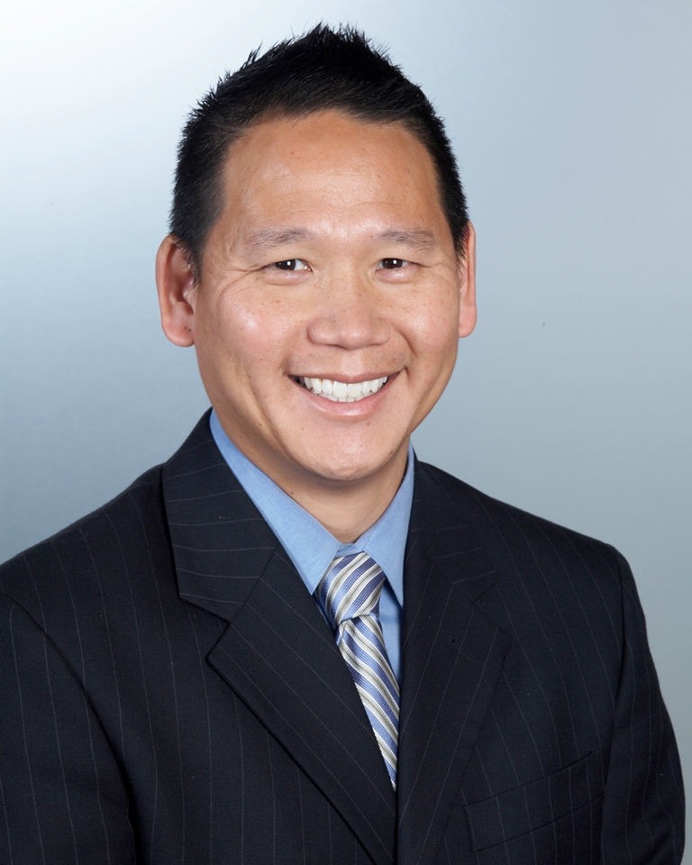
REGISTER HERE
Course Description: A common assumption in aligner therapy is that teeth that are passive in the treatment setup will not receive orthodontic forces from the aligners and should not move. While this assumption is very reasonable, clinical reports of unplanned tooth movements are beginning to appear in the literature. In other words, teeth that are not planned to move are found to have shifted. Subsequently, several research groups have provided in vitro and clinical evidence to support and explain this unusual phenomenon. This evidence-based lecture will focus on the topic of unintended tooth movements and present recommended solutions to mitigate this complication of aligner therapy. At the conclusion of this presentation, participants will have a better understanding of the phenomenon and be aware of strategies to avoid or minimize it.

Learning Objectives:
1. Be aware of unplanned tooth movements in aligner therapy
2. Understand possible reasons why unplanned movements may occur
3. Know clinical signs of unplanned tooth movement
4. Understand how aligner design can impact these unplanned movements
5. Know strategies to avoid or minimize unplanned tooth movements

Instructor Qualifications: Professor Dr. James Mah is the Interim Dean at UNLV School of Dental Medicine. He obtained his Doctorate of Dental Surgery, Master of Science degrees and his Certificate of Specialization in Orthodontics from the University of Alberta and his Doctorate of Medical Science degree from Harvard University. Dr. Mah has authored over 100 publications and several textbook chapters. His research is focused on the biomechanics of aligners, use of botulinum toxin for bruxism and biology of tooth movement. He has made over 300 national and international presentations. He also serves as Associate Editor of the Journal of Aligner Orthodontics and is a reviewer for the American Journal of Orthodontics & Dentofacial Orthopedics, Journal of Clinical Orthodontics and the Angle Orthodontist.

Requirements: Access to a computer that can play sound, is required for participation the Nevada AGD live webinar. No special computer knowledge or equipment is required to participate; however, the webinar utilizes the Zoom platform. Specific instructions will be disseminated upon registration to assist with course access.

Cancellation Policy: Cancellations by the participant before 1/16/23 will result in a fee of 50% of the tuition cost. Cancellations by the participant after 1/23/23 days or no shows will be charged the entire regular tuition price. If NV AGD cancels the program, the participant will be reimbursed the full tuition amount.

