Odontogenic Infections

Speaker: Dr. Steven Saxe, D.M.D. Date: October 26, 2022 from 6-7 pm PST
Educational Method: Lecture Subject: 310 Credits: 1
Location: Virtual Audience: General Dentists and Dental Students
Fees: NV AGD Members: $30 Non-Member: $60 Student AGD Member: $5 Non-Member Student: $10
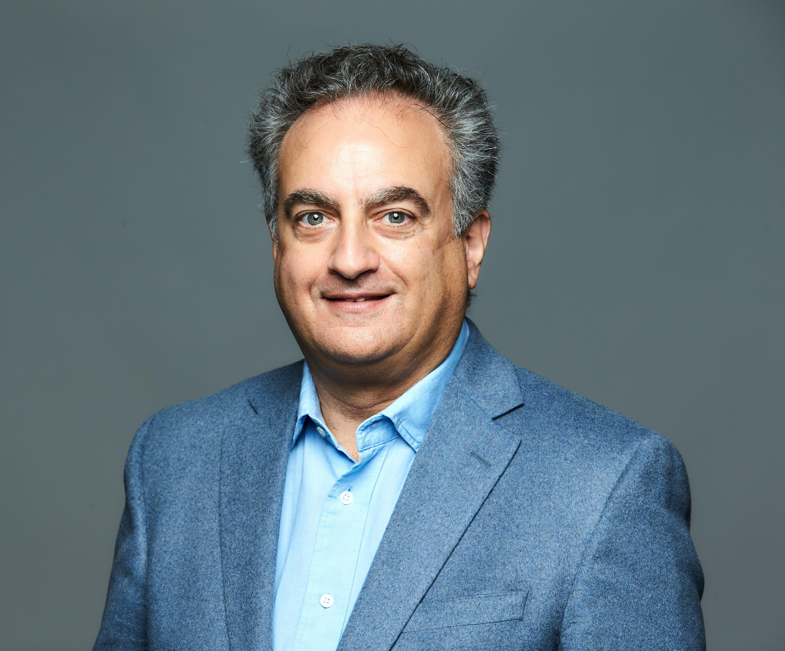
REGISTER HERE
Course Description: This course is interdisciplinary in nature and will help registrants identify pathogens and sources of infection. This course will also discuss space infections and examine necessary antibiotics used for oral infections.

Learning Objectives:
- Identify pathogens and potential sources of infection
- Review space infections
- Discuss antibiotics for oral infections
Instructor Qualifications: Dr. Steven A. Saxe joined UNLV School of Dental Medicine in 2016 as a part-time instructor and has treated patients in Las Vegas for nearly 30 years. Board certified by the American Board of Oral and Maxillofacial Surgeons, Dr. Saxe earned his bachelor’s at the University of Nevada, Las Vegas and his Doctor of Dental Medicine degree at Washington University School of Dental Medicine in Saint Louis, Missouri. He continued his education at Sinai Hospital of Detroit, completing a four-year residency in Oral & Maxillofacial Surgery. An advocate for organized dentistry, Dr. Saxe has memberships with many local, state, and national professional organizations including the Southern Nevada Dental Society, Nevada Dental Association, and International College of Dentists; is a fellow with three organizations including the American Association of Oral and Maxillofacial Surgery; a diplomate with two boards including the National Dental Board of Anesthesiology; and serves as president of the Nevada state society of Oral and Maxillofacial Surgeons. During his career, he helped found the University of Nevada School of Medicine General Practice Dental Residency, as well as the Southern Nevada Craniofacial and Cleft Palate clinic.

Requirements: Access to a computer that can play sound, is required for participation the Nevada AGD live webinar. No special computer knowledge or equipment is required to participate; however, the webinar utilizes the Zoom platform. Specific instructions will be disseminated upon registration to assist with course access.

Cancellation Policy: Cancellations by the participant before 10/12/22 will result in a fee of 50% of the tuition cost. Cancellations by the participant after 10/24/22 days or no shows will be charged the entire regular tuition price. If NV AGD cancels the program, the participant will be reimbursed the full tuition amount.
