**ChatGPT: History and Current Trends in Clinical Settings**

**Speaker:** Dr. Jyoti Mago **Date:** January 24, 2024 from 6:30-8 PM PST

**Educational Method:** Lecture **Subject:** 561 **Credits:** 1.5 **Location:** Virtual **Audience:**General Dentists, Specialists, Hygienists, Dental Students

**Fees:** NV AGD Members: $20 Non-Member: $30 Student AGD Member: $0 Non-Member Student: $5

[**REGISTER HERE**](https://agdnevada.ticketspice.com/chatgpt-history-and-current-trends-in-clinical-settings)

**Course Description:** Artificial intelligence is the most emerging and researched technology in the current times. This course is designed to understand the new Open-AI model: Chat Generated Pre-Transfer (Chat GPT) with a focus on its history, various versions, and recommendations for its use in dental healthcare in support of its literature. The course will also provide a brief overview to differentiate evidence-based dentistry and machine learning from these ChatGPT models.

**Learning Objectives:**

1. To develop an understanding of the new open-AI model in association with its history of development to its current form in support of the literature.
2. To differentiate ChatGPT from evidence-based dentistry and machine learning.
3. To analyze strengths, weakness, opportunities, and threats of ChatGPT in oral health care education, and its recommendation of use in the clinical settings.

**Instructor Qualifications**: Dr. Jyoti Mago is an Oral and Maxillofacial radiologist working as an Assistant Professor in Residence in the Department of Clinical sciences at the University of Nevada, Las Vegas. She obtained her M.S. in Dental Sciences and completed her residency training in oral & maxillofacial radiology at the University of Connecticut, School of Dental Medicine. She worked as a faculty member at the University of Iowa prior to her appointment at the University of Nevada Las Vegas. Dr. Mago has also completed her Masters in Oral Medicine and Radiology from India at Maharishi Markandeshwar University. Dr. Mago has her specialty license to practice Oral and Maxillofacial Radiology in the state of Nevada. Her keen interest is in the advanced Radiology, dosimetry, and radiation safety and protection. She is currently a fellow of Pierre Fauchard Academy. She has presented at local, national and international meetings, and has an active involvement in outreach education in radiology.

***Requirements:*** Access to a computer that can play sound, is required for participation the Nevada AGD live webinar. No special computer knowledge or equipment is required to participate; however, the webinar utilizes the Zoom platform. Specific instructions will be disseminated upon registration to assist with course access.

***Cancellation Policy:***Cancellations by the participant greater than 7 days prior to the course will result in refund of 50% of the tuition cost. Cancellations by the participant after within 7 days of the course or no shows will be charged the entire regular tuition price. If NV AGD cancels the program, the participant will be reimbursed the full tuition amount.

AGD-Nevada

Nationally Approved PACE Program Provider for FAGD/MAGD credit.

Approval does not imply acceptance by

any regulatory authority or AGD endorsement.

4/1/2022 to 3/31/2026

Provider ID# 219314

c

[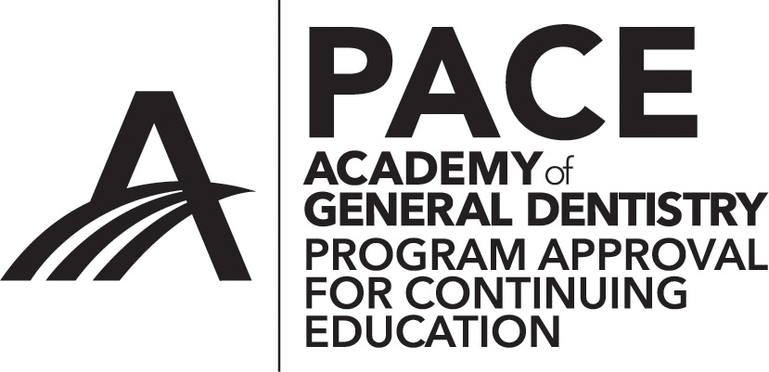](http://www.agd.org/images/logo/PACE/PACElogohires.tif)