The Golden Rules of Financial Planning

Speaker: Art Wiederman Date: February 21, 2024 from 6:30-8 PM PST
Educational Method: Lecture Subject: 730 Credits: 1.5 Location: Virtual Audience: General Dentists, Specialists, Hygienists, Dental Students
Fees: NV AGD Members: $20 Non-Member: $30 Student AGD Member: $0 Non-Member Student: $5

REGISTER HERE
Course Description: This course will give the participant a roadmap through basic debt management, retirement, savings, credit card debt, investing, insurance and basic estate planning concepts. Art talks about his rules for spending, how much you should be saving, strategies as to when to pay off your home, what types and how much insurance you should have, the importance of an emergency savings fund, the different types of retirement plans for dental practices and tips on how much you need to save and basic estate planning concepts.

Learning Objectives:
- Understand the seven areas of financial planning
- Discuss how much one should spend and save
- Convey the use of Qualified Retirement plans in a dental practice
- Determine how much life and disability insurance do you need
- Become familiar with strategies to pay off a home
- Review strategies to use and pay off credit cards

Instructor Qualifications: For more than 35 years, Art Wiederman has specialized in serving dental practices in the Southern California area. He oversees a variety of professional services including accounting, tax compliance and planning, financial planning, retirement planning and financial practice management consulting. Art’s expertise is not only in taxation issues for dentists, but also in knowledge of dental practice metrics and benchmarks. He has the ability to look at a dentist’s profit and loss statements and practice management reports and identify profit holes in the practice. In addition, Art is adept at buy-in and buy-out consulting, practice start-ups, compensation plan development, operation evaluations, and litigation support for dentists.
As an expert in dental practice accounting and financial management, Art is a regular lecturer at state, local and national dental conferences, dental societies and dental schools. He is a founding member of the Academy of Dental CPAs (ADCPA) and hosts the bi-weekly podcast, “The Art of Dental Finance and Management with Art Wiederman, CPA.”

Requirements: Access to a computer that can play sound, is required for participation the Nevada AGD live webinar. No special computer knowledge or equipment is required to participate; however, the webinar utilizes the Zoom platform. Specific instructions will be disseminated upon registration to assist with course access.

Cancellation Policy: Cancellations by participant are permitted up to 7 days prior to the event subject to a cancellation fee of 50% of the course cost. Cancellations or failure to join will not be refunded. If NV AGD cancels the program, participant will be reimbursed the full tuition amount.
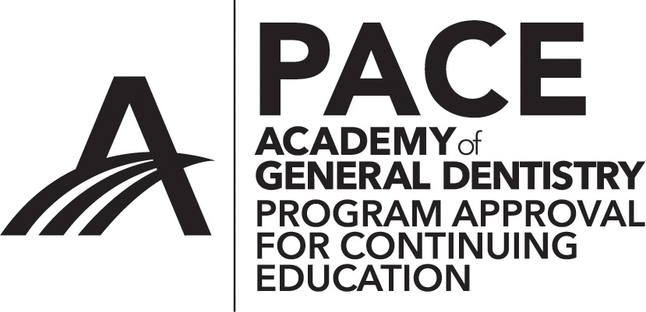
AGD-Nevada
Nationally Approved PACE Program Provider for FAGD/MAGD credit.
Approval does not imply acceptance by
any regulatory authority or AGD endorsement.
4/1/2022 to 3/31/2026
Provider ID# 219314

c

