Pathway to Fellowship
October 10 - 12, 2025
Marriott Irvine Spectrum
7905 Irvine Center Dr., Irvine, CA

Early Bird Registration BEFORE 9/10/25

$850 for AGD members; $1,600 for non-members before 9/10/25
$1,050 for AGD members; $1,900 for non-members after 9/10/25

Friday, October 10, 2025
8:00am to 5:00pm
Sheela Roth, RDH BS: The Future is Now: Harnessing AI in Dentistry for Diagnosis, Treatment, and Practice Efficiency
8 lecture CE
AGD subject code 550 (Practice Management)

Sponsored by Pearl
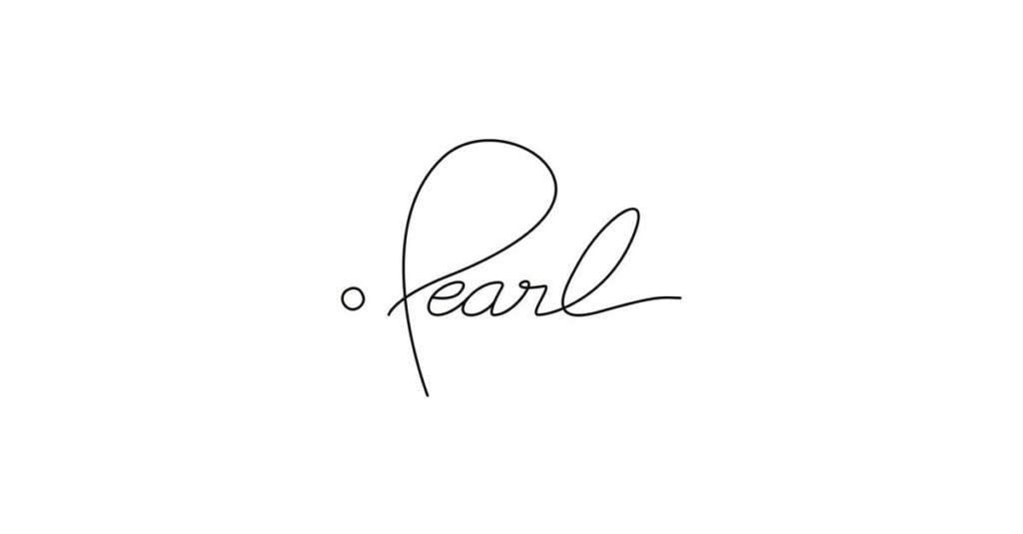
This 8-hour CE course gives dental professionals a comprehensive look at artificial intelligence and how it’s shaping modern dentistry. Attendees will explore the science behind AI, its clinical applications in diagnostics, treatment planning, and insurance workflows, and how to evaluate and implement AI tools in practice. The course includes interactive elements, such as real-time software demonstrations and a hands-on segment where participants will “test their skills” by using AI tools to analyze cases. Attendees will leave with a clearer understanding of how to ethically and effectively integrate AI into daily workflows to improve outcomes, increase efficiency, and elevate patient care.

Objectives:

- Explain the foundational science behind artificial intelligence and its application in diagnostic imaging, treatment planning, and administrative tasks in dentistry.
- Evaluate and apply AI tools in real-time clinical scenarios to improve case acceptance and streamline documentation.
- Identify practical strategies for successfully integrating AI into their dental practice while maintaining compliance with regulatory and ethical standards.

Sheela Roth is an experienced dental practice management expert, thought leader, and public speaker. As Director of Clinical Operations at Pearl, a dental AI company, she leads a team focused on practice transformation and improving clinical performance. Before this, she founded and led Absolute Dental Business Solutions, a practice management consultancy. She holds a Bachelor of Science degree from Loma Linda University and is a Registered Dental Hygienist.
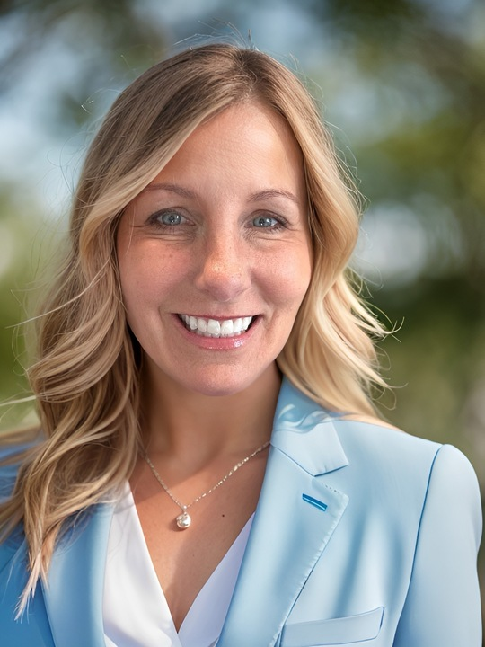

Saturday, October 11, 2025
8:00am to 5:00pm
Dr. Mina Levi: Introduction to Clear Aligner Orthodontics—A 2-Part Course
8 lecture CE
AGD subject code 370 (Orthodontics)

SPONSORED BY INVISALIGN
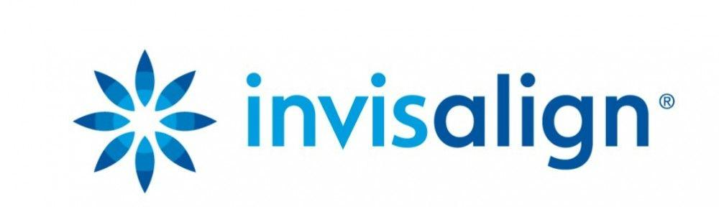
8:00am – 12:00pm
Six Business Engines of a Successful Invisalign Diamond Dental Practice

Course Description & Objectives:

By the end of this course, participants will understand and be able to implement the six core business engines that drive growth, efficiency, and profitability in a high-performing Invisalign Diamond dental practice. The course will equip dental professionals and practice managers with the strategic knowledge, operational tools, and performance benchmarks necessary to elevate their Invisalign business to the Diamond level. Learners will gain insights into patient acquisition, case acceptance, clinical systems, team performance, financial optimization, and brand positioning—all tailored specifically to the Invisalign practice model.

1:00pm – 5:00pm
How To Start Treating Patients with Invisalign Clear Aligners

Course Description & Objectives:

By the end of this course, participants will be equipped with the foundational knowledge and clinical confidence to begin treating patients with Invisalign clear aligners. The course will cover patient selection, digital case submission, treatment planning with the ClinCheck® software, and aligner delivery protocols. Attendees will also learn best practices for effective patient communication, managing treatment progress, and integrating Invisalign into their practice workflow to ensure successful outcomes from day one.

About the Speaker

Dr. Mina Levi received her dentistry degree from Sofia Medical University and did her post-graduate studies in orthodontics at Plovdiv Medical University in Bulgaria. She also studied dentistry at UCLA upon moving to the United States.

Dr. Mina Levi was the past president of the Northern California Chapter of the Academy of General Dentistry. She holds a Master of the Academy of General Dentistry and a Master of the American Academy of Clear Aligners. Dr. Mina Levi is a Fellow of the Academy of Dentistry International and a Fellow of the International College of Oral Implantologists.

Dr. Mina Levi received advanced training in orthodontics in Germany and in dental implants in the US. She was the first dentist in California to become certified in Zirconia metal-free dental implants in 2008. Dr. Mina Levi’s clinical approach is to be minimally invasive and to preserve as much as possible of the natural tooth structure by following a Biomimetic Approach taught by Dr. Pascal Magne. She enjoys helping patients reinvent their smiles.

Dr. Mina Levi has been a Diamond Invisalign provider. She is involved with the America Academy of Clear Aligners and has been running the AACA Dental Study Group in San Francisco dedicated primarily on improving clinical and management skills of general dentists in the Bay Area when treating patients with clear aligners.

Dr. Mina Levi has been involved with AGD since 2008. She currently serves on the PACE committee reviewing multiple CE PACE applications every year.

In her free time, Dr. Levi enjoys hiking, skiing and macro photography.

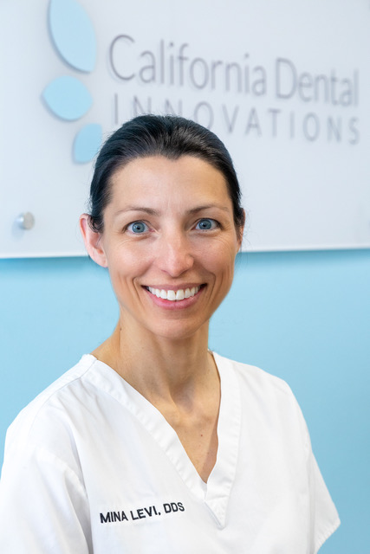

Sunday, October 11, 2025
8:00am to 12:00pm
Dr. Mark Porco: Forensic Odontology for the Dental Professional: It’s Not
Always a Grave Situation
4 lecture CE
AGD subject code 130 (electives)

Do you ever see the headlines of some disaster and wonder how or why some of the victims are identified by dental records? Dr. Porco will discuss the various disciplines in the forensic sciences, with emphasis on Forensic Odontology. This will include a brief history lesson, case presentations, “testing” of your forensic skills, and then followed by how this applies to your dental office and every member of your dental team.

This course will discuss multiple forensic cases from the coroner’s office. It will be shown how the identifications were made through dental records. The need for keeping accurate dental records will be made apparent. The presentation will culminate by answering the question of why this work is vital to the coroner’s office and the families involved.

Learning Objectives:
• How a dental identification is made
• Which dental records are important, and why
• How this work helps our communities

Mark Porco, DDS received his DDS degree from Loma Linda University School of Dentistry in 1988. Following graduation, he and his wife lived and worked in Trinidad and Tobago in the West Indies for two years. Until recently he maintained a solo practice in general dentistry for 29 years in Lincoln, California. Dr. Porco has been a member of the Sacramento District Dental Society’s Mass Disaster/Forensics Committee since 2000, and chairman of the committee since 2011. He has been fascinated with forensics since taking an elective course his senior year in dental school. While attending many seminars on forensics over the years, he has been actively pursuing his forensic education since attending the Southwest Symposium in 2012. He joined the American Society of Forensic Odontology in 2012 and the American Academy of Forensic Sciences in 2013. He has been a member of the Disaster Mortuary Operational Response Team IX since 2014. Currently, Dr. Porco serves as the Forensic Odontologist for Sacramento and San Joaquin Counties
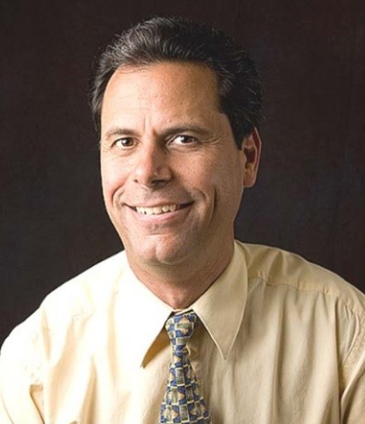

Refund and Cancellation Policy:
- Registrations are subject to a $75 non-refundable processing fee.
- Cancellations made by email prior to 9/25/25 will receive a refund less the $75 processing fee.
- Cancellations made after 9/25/25 are completely non-refundable.
- Transfer of a registration to another name will be considered by email request through 9/25/25.

https://bit.ly/4lommbR


