Temporomandibular Joint Disorders: Imaging, Diagnosis, and Advanced Treatment

Dr. Rebeka Silva
Saturday, May 24, 2025
9:30am to 11:30am
The Officer’s Club
3410 Westover Street, Sacramento (McClellan), CA 95652

$99 for AGD members; $30 for staff of AGD members (with paid AGD member); $179 for non-AGD members; $60 for staff of non-AGD members
Includes light breakfast

2 lecture CE AGD Subject Code 200 (Orofacial Pain)

This two-hour course will start with a review of the different intra-articular and extra-articular conditions that affect the temporomandibular joint, with a focus on the most common conditions, including internal derangement, degenerative joint disease and myofascial pain. MRI and CT imaging techniques will be reviewed, highlighting the advantages of each type. An overview of the available surgical modalities will be discussed and indications for different therapies will be discussed. Finally, understanding how Botox can be helpful and when it is indicated will complete this overview of TMJ pathology and myofascial pain.

Objectives:
- The participant will be able to describe the different TMJ imaging modalities, and strengths and weaknesses of each.
- The participant will be able to identify the different findings within categories of TMJ internal derangement, degenerative joint disease, and myofascial pain.
- The participant will be able to compare the different surgical modalities available in the treatment of TMJ disorders and understand why it is selected.
- The participant will understand how Botox works and why it is useful in particular scenarios.

Rebeka Silva, DMD, FACD is Clinical Professor of Oral and Maxillofacial Surgery at the University of California, San Francisco, and she also serves as Chief of Dental Service and full-time oral and maxillofacial surgeon at the San Francisco VA Medical Center. In addition, she has a part-time private practice in San Francisco at Song Oral Surgery and is an attending surgeon at California Pacific Medical Center. Dr. Silva has co-authored three textbooks on the contemporary management of TMJ disorders and has published peer-reviewed papers in the field. In addition to presenting at national and international meetings, Dr. Silva was nominated to the prestigious American Society of TMJ Surgeons.

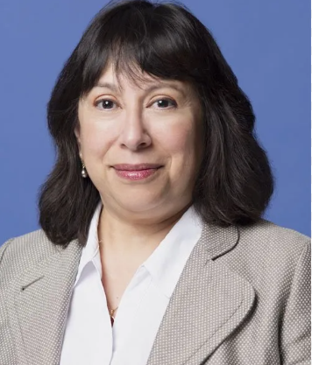

https://bit.ly/42ozmr3
