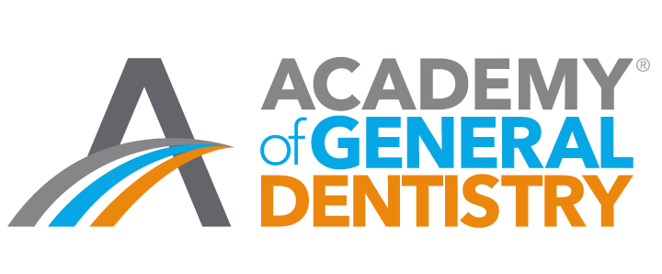
Academy of General Dentistry Program Approval for Continuing Education (PACE)

Electronically Mediated CE Course Report – LOCAL PROGAM

LIST OF UPCOMING ELECTRONICALLY MEDIATED CONTINUING DENTAL EDUCATION EVENTS

Title of Activity | Date(s) Offered | # of CE Hours to be Awarded | Expected # of Participants | Prerequisite (Yes/No) | Offered with another Program Provider? (Yes/No) | Received outside financial support (Yes/No)

When complete, save form to your computer and then upload to the AGD web form.

